From: Dawn Lowry
Sent: Tuesday, March 15, 2011 1:22 PM
To: Dawn Lowry
Subject: Ship Lines Suspend Service at Three Japanese Ports

Ship Lines Suspend Service at Three Japanese Ports
Peter T. Leach | Mar 15, 2011 5:00PM GMT
The Journal of Commerce Online - News Story
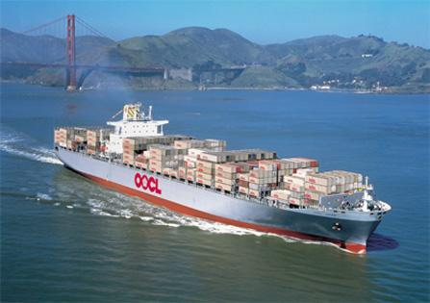
Service to six others limited by rolling blackouts
Shipping lines suspended service to three Japanese ports that were hit by Friday's tsunami but continues to serve six other ports where rolling blackouts are limiting operations.
The ports of Sendai, Onahama and Hachinohe are closed because their terminals suffered some damage," said Mary Ann Kotlarich, a spokesperson for Maersk Line in the U.S. She said Maersk is not accepting booking at these ports until more information can be obtained.
"The ports of Tokyo, Yokohama, Nagoya, Kobe, Osaka and Hakata are open and operating, and we are accepting bookings to and from these ports, although they were closed on Friday," Kotlarich said.
Because the six ports were closed on Friday after the earthquake, they are experiencing some congestion. OOCL said it was dropping shipments for ports affected by the tsunami at Tokyo or Yokohama. OOCL also declared force majeure on Sendai-based shipments on the NYK Themis, part of a vessel sharing arrangement, and said it would be up to customers to arrange cargo transport from Tokyo. In addition, Tokyo and Yokohama are experiencing rolling blackouts of one to three hours per day, which is disrupting normal loading and unloading operations, Kotlarich said.
"Maersk has 300 employees in Japan, and all of them are reported safe," she said.
The carrier's offices were not damaged by the earthquake and remain open, although planned rolling blackouts have disrupted the workers' commuting schedules. "Not all of the employees have been able to get to work."
One of Maersk's container ships had just left dock in one of the Japanese ports on Friday when the earthquake hit. It experienced heavy rolling during the tsunami but was not damaged, Kotlarich said.
Maersk said it continues to serve other Japanese ports as usual for now, but service may be subject to changes later.
-- Contact Peter T. Leach at pleach@joc.com.

